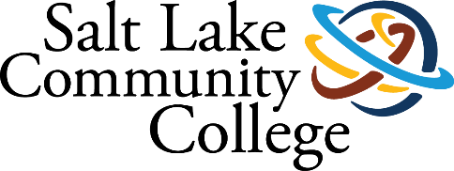 | ACADEMIC ADVISING
2019-2020 ANNUAL ASSESSMENT
SUMMARY OF RESULTS

Project Title: Case Management Advising

College-wide Strategic Goal: Increase Student Completion
Strategy No. 1: Implement SLCC Pathways
Create and integrate guided areas of study intentionally designed to enhance learning and clarify a student's route to program completion, a career and further education. Successful implementation will provide a holistic academic advising and student-supported experience while reinforcing student development.

Assessment Overview: Holistic Advising
The purpose of the holistic or “case-management” advising is not only to provide student support through completion, but also encourage persistence from semester-to-semester and year-to-year. Academic Advisors will, through establishing mentor-like support and clear communication across a supportive network, coach the student through how to evaluate and adjust their goals; understand their priorities within the changing contexts of their lives; provide students with just-in-time feedback, meaningful interventions, relevant referrals, and direction to navigate higher education; how to create and modify an academic plan; and how to identify their support network.
The structure for case managed advising establishes key milestones for students. These milestones are widely communicated so both the student and their Academic Advisor know the purpose for student engagement in the academic advising process. Once the advising expectations are set, college personnel and students can better identify the support the College needs to provide to encourage students to complete mandatory and recommended activities.

Methodology (Plan/Method)

Automated Dashboards at performance.slcc.edu
Academic Advising worked with Data Science and Analytics to create high-level summaries of case-management advising on the Pre-enrollment Dashboard available on the SLCC website. The pre-enrollment dashboard is still being refined and tested but gives a cursory glance at student success in the case-management cohorts up to this point.
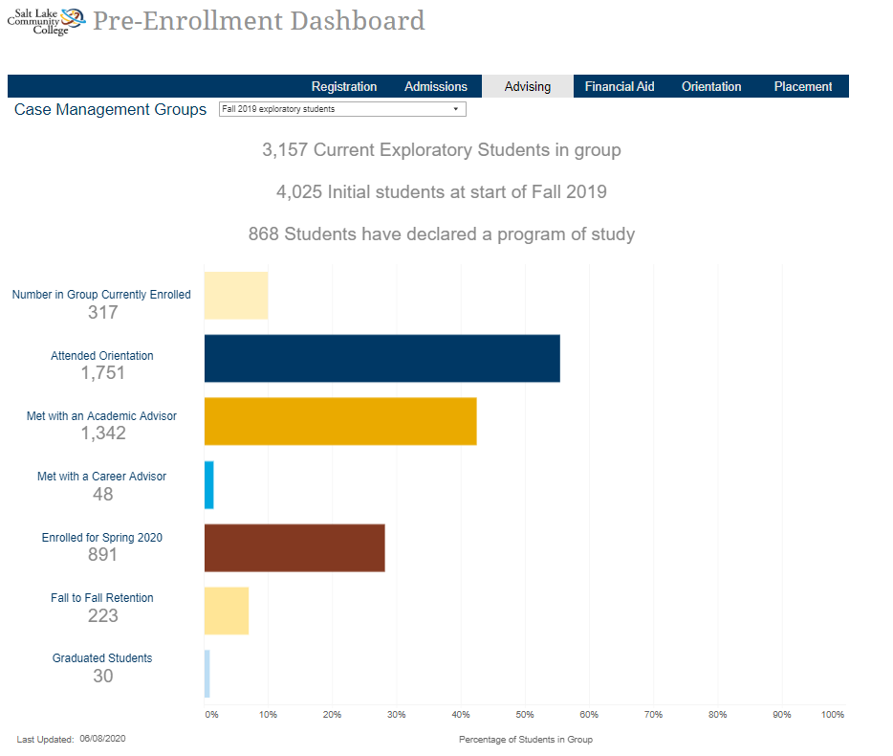
Figure 1 Screenshot of Pre-enollment Dashboard

Touchpoint Tracking using MySuccess
The original plan for Touchpoint Tracking included the touchpoints listed below.
Recommended Touchpoint | MySuccess Tracking Item
1st contact-Introductory Email | 1st Contact Flag
2nd contact-Personalized Email | 2nd Contact Flag
3rd contact-phone call | 3rd Contact Flag
Student Responded to Contact | Thanks for responding kudo
Intake Form | You’ve completed the intake form kudo
1st Mandatory Appointment | 1st Mandatory Appointment Success Plan
2nd Mandatory Appointment | 2nd Mandatory Appointment Success Plan
Success Plan | Alternate milestone or academic standards success plans
DegreeWorks Plan for 2+ Semesters | DegreeWorks Plan-2+ Semester Kudo
DegreeWorks Plan to Completion | DegreeWorks Plan-Completion Kudo
Graduation Application | Graduation Application Flag/Kudo
Stop-out Counseling (for deferrals, transfer, or graduates) | Stop-out Notes

These original touchpoints proved to be too time-consuming for advisors, so they have reduced to the following touchpoints.
Recommended Touchpoint | MySuccess Tracking Item
1st Mandatory Appointment | 1st Mandatory Appointment Reason Type
2nd Mandatory Appointment | 2nd Mandatory Appointment Reason Type
DegreeWorks Plan | DegreeWorks Indicator for Active Plan
Graduation Application | Graduation Application Code in Banner
Stop-out Counseling (for deferrals, transfer, or graduates) | Stop-out Notes (Deferral Application?)

Advisors were given individual spreadsheets to track these touchpoints while an automated dashboard was created. Unfortunately, the ability to break up advising caseloads using technology was not completed until May 2020 and the advisor dashboards delayed into the 2020-2021 academic year.

Student Surveys
Academic Advising planned to use two student surveys to capture qualitative data on the students’ competency of the identified learning outcomes and their experiences with their academic advisor, an annual survey showing their competencies in advising learning outcomes and a daily survey to assess success of individual advising appointments.

Annual Milestone Survey
The annual survey that was planned for May was postponed as offices moved off-site due to COVID-19. It has been rescheduled to go out in July 2020.

Daily Satisfaction Survey
Academic Advising started sending surveys out to all students with appointments each day starting on March 20, 2020. The response rate is 9.9% and with a total of 218 total respondents. Ethnicity and gender demographics of respondents are below.
Race/Ethnicity Distribution
Gender Distribution

The daily survey has the following questions that required a response on the 5-point Likert scale for the following questions.
- The Academic Advisor was knowledgeable and able to explain the requirements of my program.
- After meeting with the Academic Advisor I felt more prepared to meet my goals.
- The Academic Advisor was able to explain how to find information about the resources and support services on campus.
- I would return to see Academic Advising
- I would recommend other students meet with an Academic Advisor.
The survey responses are as follows:
The Academic Advisor was knowledgeable and able to explain the requirements of my program.

After meeting with the Academic Advisor I felt more prepared to meet my goals.

The Academic Advisor was able to explain how to find information about the resources and support services on campus.

I would return to see Academic Advising.

I would recommend other students meet with an Academic Advisor

The Daily Survey also included the two open-ended questions.
- Do you have additional questions or comments that were not addressed? What went well? What could be improved?
- Would you like to have someone contact you regarding your appointment? If yes, please provide your student number. A staff member from Academic Advising will follow up with you to review the additional comments or questions you have.
A member of the Academic Advising Leadership team follows up with any requests for comments where the student has included their student number.

Results/Findings

Pre-Enrollment Dashboard
By accessing the pre-enrollment dashboard we can see a breakdown by case management cohort. For example, the first cohort available are the students in the Business Pathway pilot that included new freshman that started in the Business area of study in Fall 2018. Of 230 students, 91% attended orientation, and all except one student that attended orientation met with their academic advisor. Fall-to-Spring retention was around 66% and Fall-to-Fall retention around 53%. Only 8% have graduated after 2 years. Institutionally, Fall-to-Spring retention was 68% and Fall-to-Fall Retention was 48%. Empirically, retention only slightly improved Fall-to-Fall retention compared to other students in the School of Business. The College fact book only shows 6-year completion to further comparison is needed.

Touchpoint Tracking Using MySuccess
The original plan for Fall 2019 tracking key touchpoints for students and advisors included flags and kudos in MySuccess for contacts, responses, meetings, and data that was not readily available in MySuccess. The number of notifications that were going out to students and the amount of work this created for the advisors proved to be overwhelming. The leadership team then modified the touchpoints to things that were tracked already through advisors’ daily processes, such as meeting notes, and items that could possibly be pulled into an automated report from MySuccess and other systems.
The modified plan beginning Spring 2020 shows meeting data on the pre-enrollment dashboard, but the key piece of having individual advisor dashboards was dependent on advisor-to-student assignments in Banner. The advisor-to-student assignments were not completed until May 2020, advisors are now able to do outreach to their caseloads in MySuccess and view if students have any MySuccess tracking items such as kudos or flags. Very early findings indicate that students are more likely to meet with/contact their correct advisor and more students have up-to-date plans in DegreeWorks. More information is needed to show any other improvements or depreciations in student retention or completion.

Annual Milestone Survey
The Annual Milestone Survey for 2019-2020 has not yet been deployed.

Daily Satisfaction Survey
Academic Advising established strong baseline data from the student satisfaction survey during a time that the department shifted to online only services. We will be able to compare these findings to our in-person appointments as students and staff return to campus. Overall findings show many students are satisfied with their advising experience, but there is room for improvement.

Action Plan (Use of Results/Improvements/Call to Action)

Pre-enrollment Dashboard
- Add 2020-2021 case management cohorts in performance dashboards
- Add ability to disaggregate by race/ethnicity and gender.

Touchpoint Tracking Using MySuccess
- Develop with Data, Science and Analytics an advisor dashboard modeled after faculty dashboard that advisors can use to track key touchpoints and prioritize caseloads.
- Add ability to disaggregate data by race/ethnicity, gender, age, Academic Standing
- Utilize predictive data to show how advisor performance contributes to the College’s overall strategic plan.

Annual Milestone Survey
- Launch survey July 2020 and compare with responses from 2019 Business cohort survey.

Daily Satisfaction Survey
- Move the Daily Satisfaction Survey from Campus Labs to Qualtrics.
- Add questions to assess differences in satisfaction from in-person, phone, or virtual appointments.
- Automate survey invitations to go out automatically with OIT.
- Develop unique survey links with DSA to attach responses to individual advisors and/or Areas of Study.

Timeline
Ongoing – Send out daily student satisfaction surveys.
June 2020 – Add 2020-2021 Case Management Cohorts to performance.slcc.edu dashboard
July 2020 – Launch Annual Milestone Learning Outcomes Survey from Qualtrics
July 2020-December 2020 – Develop Advisor Dasboard with Data Science and Analytics divided advisor caseloads and tracking key touchpoints.
January 2021-August 2021 – Develop Advisor Supervisory Dashboard with Data Science and Analytics to track student performance divided by Pathway
May 2021-Launch Annual Milestone Learning Outcomes Survey

Other Notes

